Use wireshark to check ECN header:  
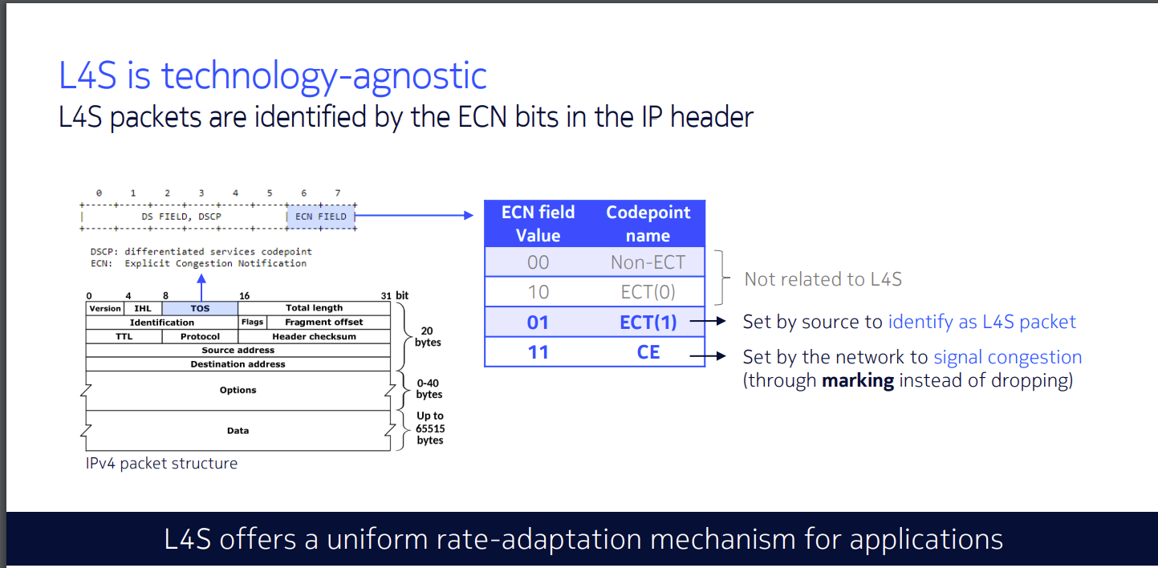

We can use the command “**ip.dsfield. ecn==X**” to check if the packet has an ECN header

**ip.dsfield. ecn==1** “This filter is used to display packets in which the ECN field in the IP header is 01 (ECT(1)). This means that these packets have ECN enabled and are using the ECT(1) mark.”

**ip.dsfield. ecn==3** “This filter is used to display packets in which the ECN field in the IP header is 11 (CE). This means that these packets have experienced congestion during transmission, and the network device has set the CE mark.”

Case: ECN enabled 1 flow

Ip 192.168.4.15 = client 1 prague

Ip 192.168.4.8 = client 2 cubic

ECT(1) and ECN 01 means this packet is set by source to identify as L4S packet

We can see that all Prague packets are marked as L4S packets

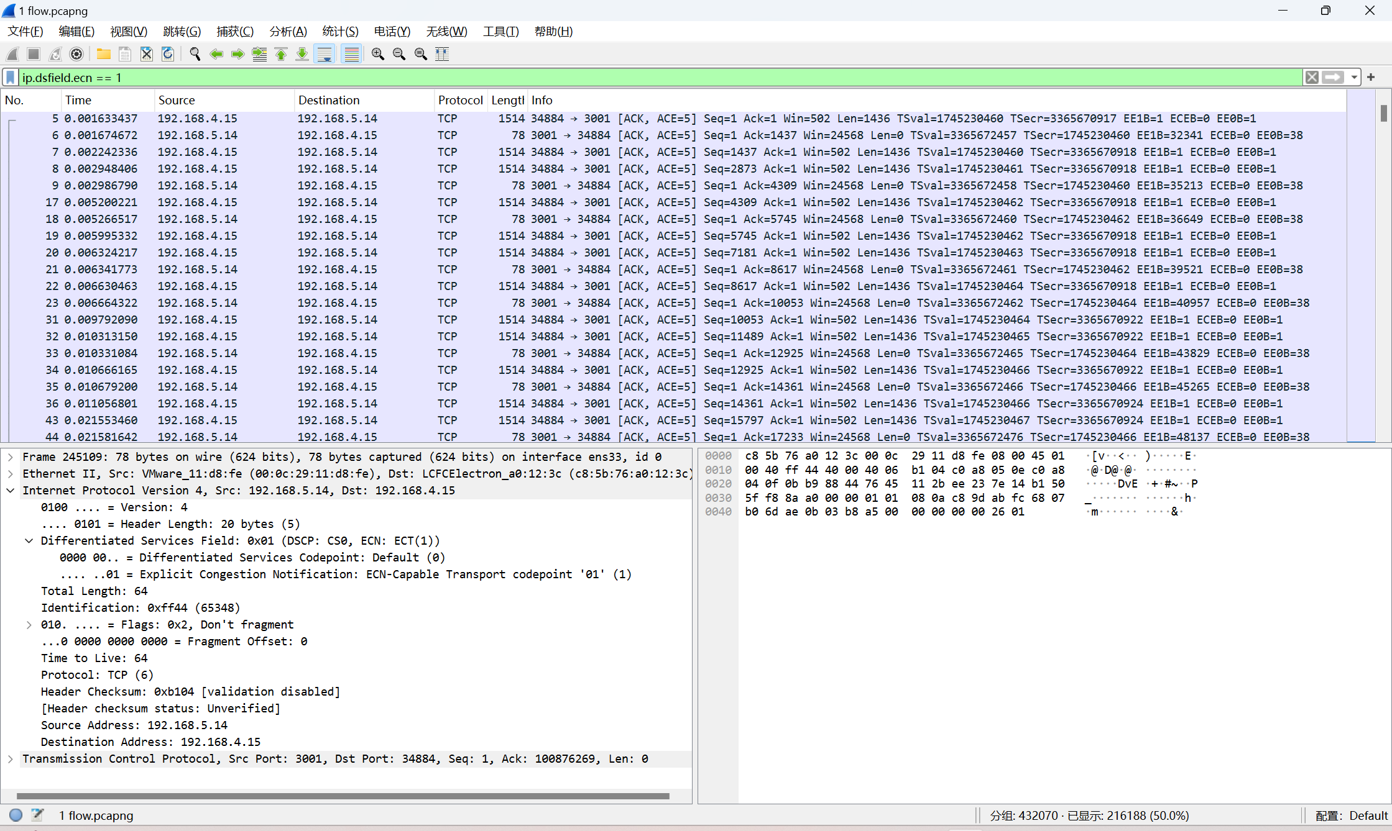

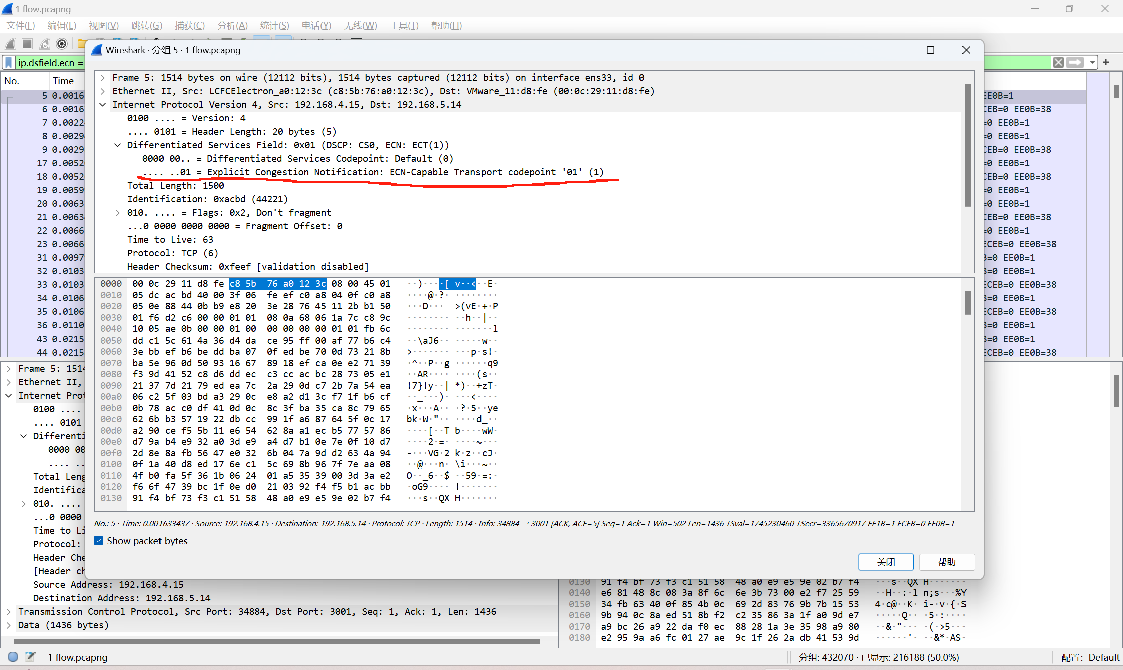

All cubic packets are not marked as L4S packets

ECT(0) and ECN 10 not related to L4S

ECN 10 means ECN enabled

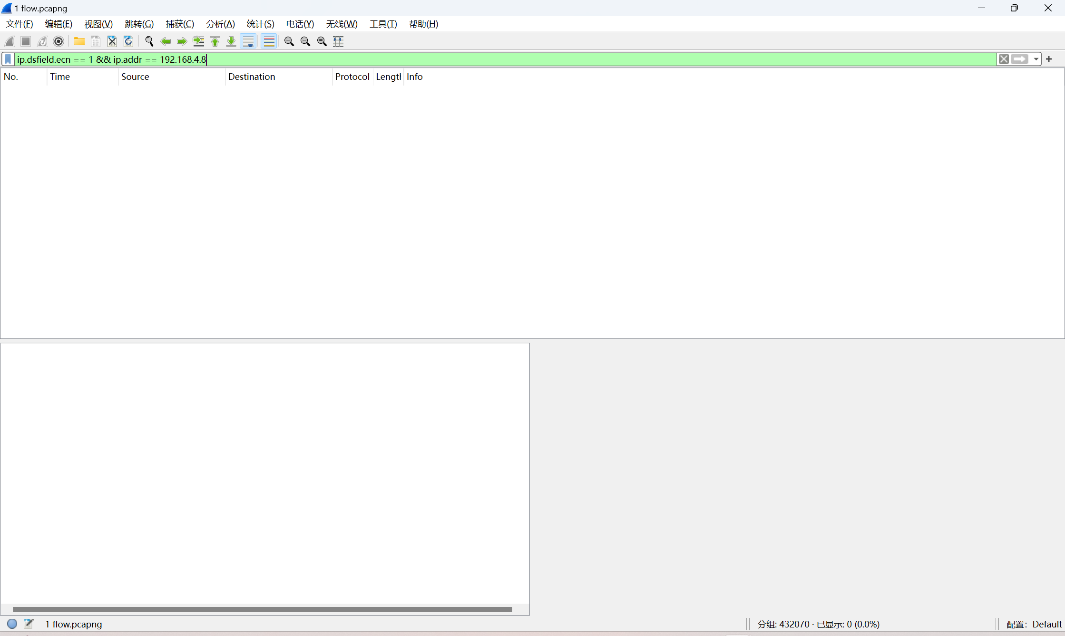

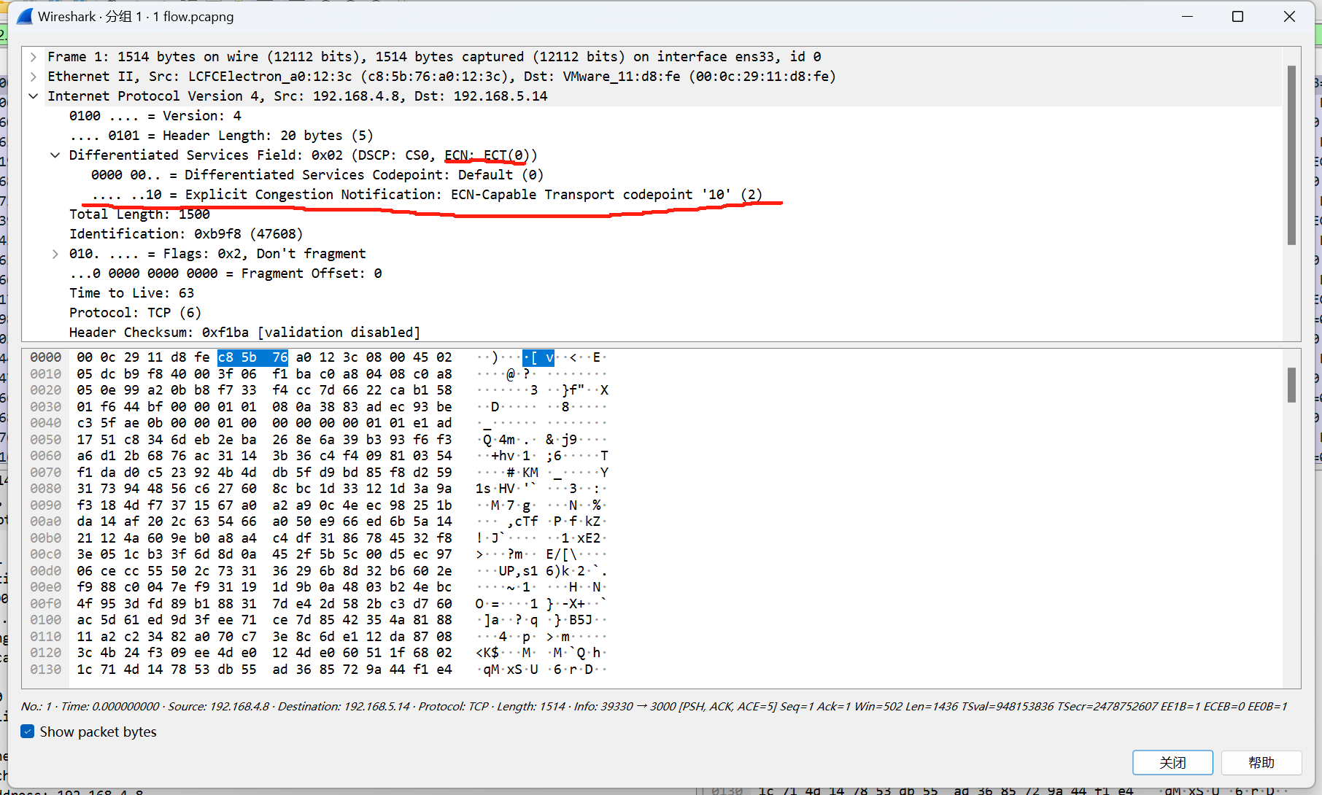

By finding the packet with an ECN field of 3 (CE), I can confirm that the network device detected congestion during transmission and notified the prague enabled client 1. Subsequently, client 1 will adjust the sending rate to alleviate congestion.

ECN (CE) and ECN 11 means the network device detected congestion during transmission and set the ECN field to 11 to notify the receiver of the congestion situation.

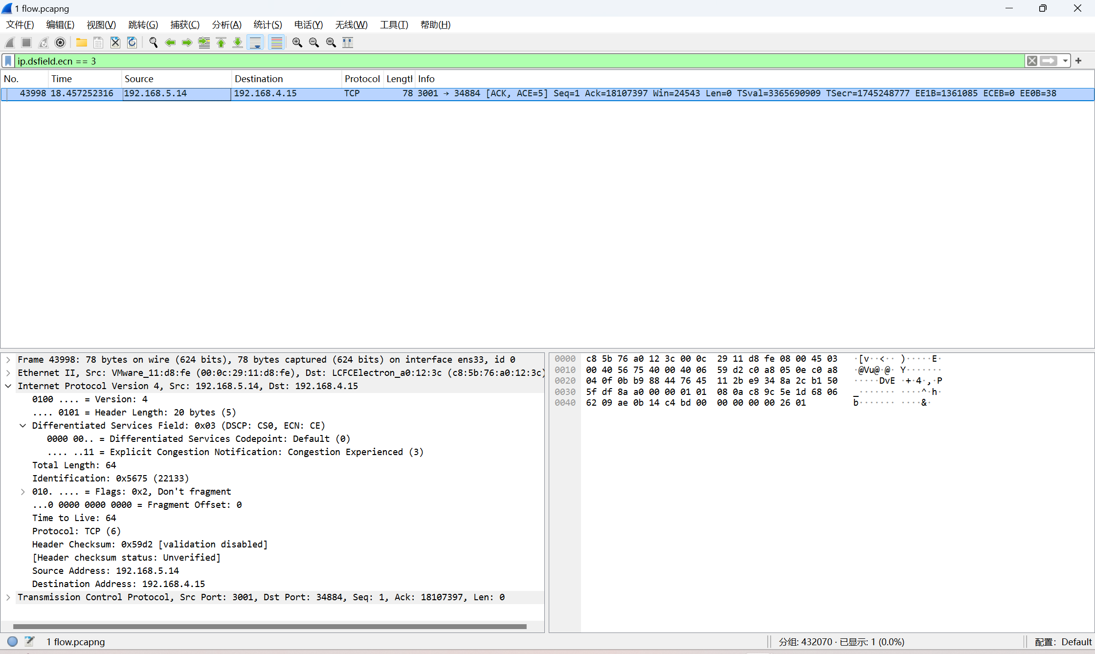

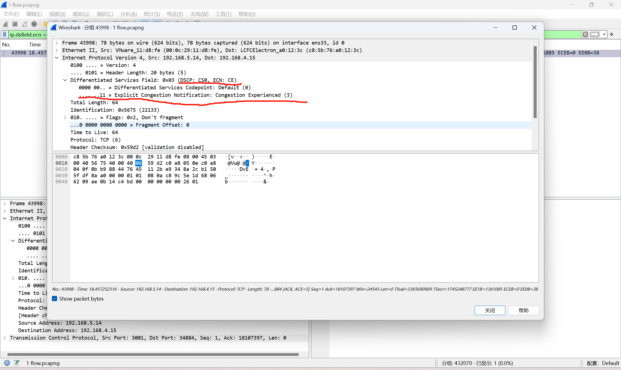

You can see that when the flow of each client is 4, we can see more packets marked with ECN field 3 (CE). This indicates that in this situation, network devices detect congestion more frequently and notify the receiver through ECN mechanisms.

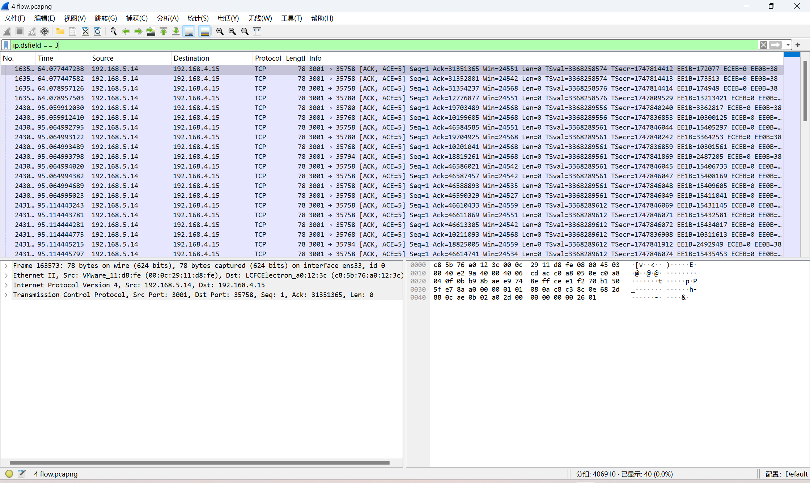

Case: ECN disabled 2 flow

We have disabled ECN on each client, so now all packets will not have ECN markings.

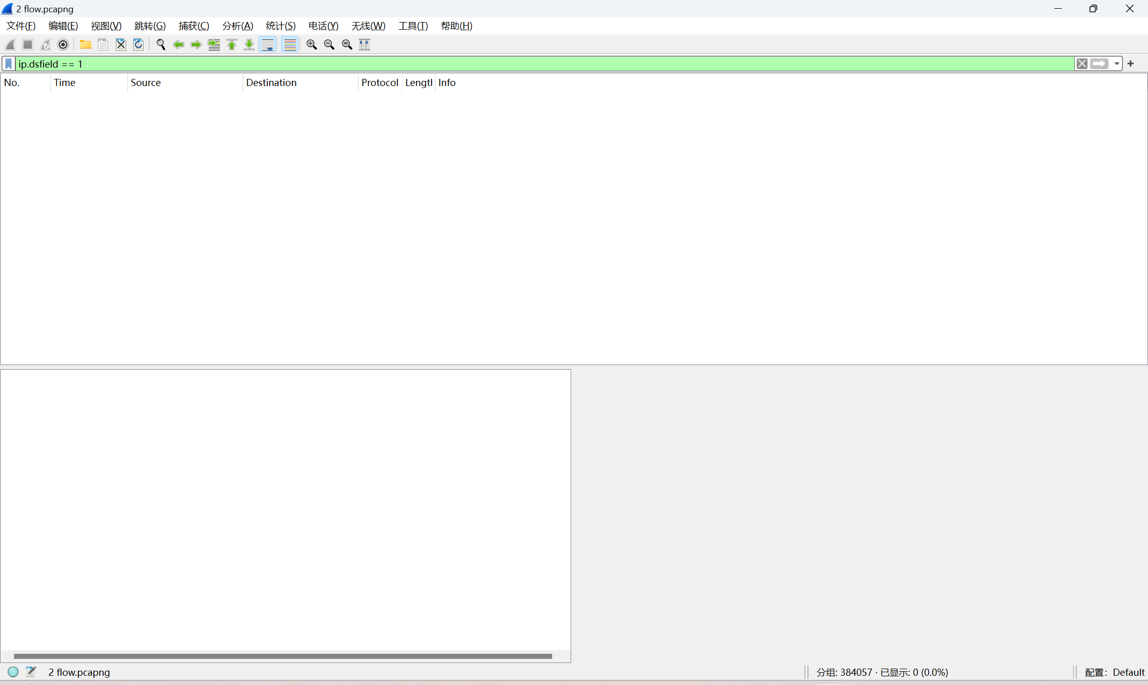

Observation:

1. With ECN enabled, we observe no retransmissions, which indicates that there is no packet loss. However, with ECN disabled, retransmissions still happened. This demonstrates that using DualPI2 alone does not prevent packet loss, and packet loss can only be avoided by enabling ECN in conjunction with DualPI2.
2. Regardless of whether ECN is enabled, as long as DualPI2 is used, the average throughput of Prague and CUBIC becomes relatively close. In most cases, their fairness ratio is around 0.49 and 0.51. This suggests that DualPI2 might be responsible for making the throughput of Prague and CUBIC more similar.
3. If ECN is enabled, the throughput of both clients will not be greater than the throughput with ECN disabled. However, with ECN enabled, the latency will be lower than when ECN is disabled."
4. While conducting experiments, it was found that when both Cubic and Prague were set to 10 flow, retransmission (retransmission) occurred in both clients. We have analyzed the situation, and we are now speculating that there are two possible reasons for this:

Excessive load: Due to the high load caused by 10 flow, the network devices (e.g., routers) may not be able to process all packets in time, resulting in packet loss and retransmission.

Soft router performance limitation: The processing power of the soft router may be insufficient, resulting in the inability to provide sufficient throughput in high traffic situations, which triggers packet loss and retransmission.